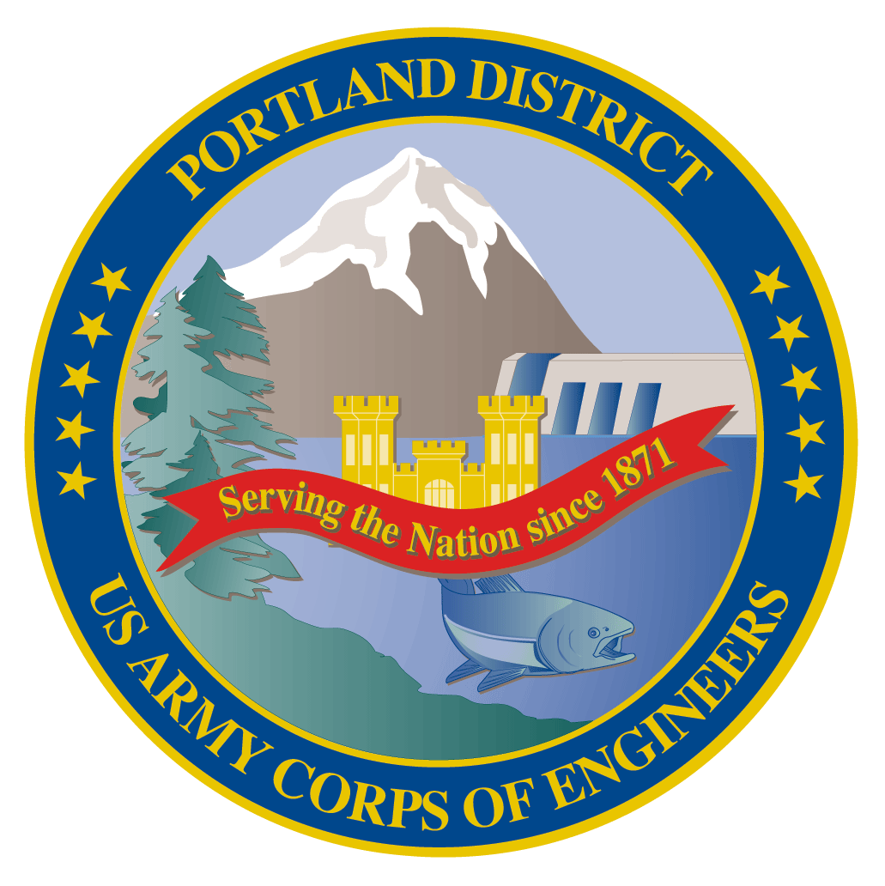
Lower Columbia River Fish Facility Design Review Work Group (FFDRWG)

USACE, Portland District

April 2022 Meeting Notes
  - April 7, 2022, 09:00-09:40 (new record)

FFDRWG meeting Files
http://pweb.crohms.org/tmt/documents/FPOM/2010/FFDRWG/2022%20FFDRWG/

Introductions

BPA

Scott Bettin
Kim Johnson
Siena Lopez-Johnston

Christine Petersen
Greg Smith
Leah Sullivan
Ben Hausmann
NOAA
Blane Bellerud

Gabriel Brooks
Trevor Conder

Kinsey Frick
Claire McGrath
Josie Thompson

Logan Negherbon
USFWS

Dave Swank
States

Erick Van Dyke (ODFW)

Charles Morrill (WDFW)
Jonathan Ebel (IDFG)
CRITFC/Tribes
Tom Lorz (CRITFC)
Blaine Parker (CRITFC)
Tom Skiles (CRITFC)

Laurie Porter (CRITFC)

Greg Silver (CRITFC)
Casey Baldwin (CTCR)
Michael Karnosh (CTGR)
Lawrence Schwabe (CTGR)
Torey Wakeland (CTGR)
Aaron Jackson (CTUIR)

Ralph Lampman (YN)

Lindy Collamer (CTWSBNR)
NPCC
Leslie Bach
Kris Homel
FPC

Erin Cooper
PSMFC
Alan Brower
Darren Chase
Roger Clark
Mark Leonard
Scott Livingston
Nicole Tancreto

Don Warf
CENWD

Doug Baus
Tim Dykstra
Dan Feil
Mike Langeslay
Cindy Studebaker

Lisa Wright
CENWW
Karl Anderson

Chris Peery
Steve Juhnke
Denise Griffith
Kenneth Fone
Bobby Johnson
CENWP-OD
Andrew Derugin
Rebecca Cates

Jeanette Wendler
Tucker Gossett

Bob Cordie
Jeffrey Randall

Eric Grosvenor

Michael Lotspeich
Laura Rickets
Tammy Mackey
Darren Gallion
Robert Wertheimer
Karrie Gibbons
CENWP-PM
Jim Adams
Michael Carl
Ian Chane
Jeff Hicks
Steve Sipe
Jeremiah Woodard
Erin Kovalchuk
Mark Bierman
Brad Eppard
David Griffith
Fenton Khan
Rachel Laird

Nathan McClain

Jake Macdonald
Scott Fielding
Rich Piaskowski
Jon Rerecich
Ida Royer
David Trachtenbarg
CENWP-ENC
Adam White
Brandt Bannister
Bridget Bell

Shari Dunlop
Curtis Lipski

Chris Motti

Steve Schlenker

Max Wilson-Fey
Mehdi Roshani
Collin Porter
Dan Pen

Action items from previous meetings
- Corps will present The Dalles backup AWS debris management alternatives at an upcoming FFDRWG
  - EDR shelved at 50% with no funding in FY 22. The Corps will walk through alternatives with FFDRWG at 60% (when the project resumes)
- Corps will upload the adult lamprey passage DDR’s to the FFDRWG meeting files website.
  - 60% JDA Lamprey Passage Improvements DDR is available
    - link is dead, thanks to Dave Swank for noticing. ACTION: Tammy Mackey will fix broken link to JDA Lamprey Passage Improvements 60% DDR on the 2022 NWP FFDRWG Meeting Files site.
  - 30% TDA East Fish Ladder LPS DDR is available
    - 60% coming soon (don’t spend too much effort reviewing 30%)
  - 30% BON2 Control Section Redesign DDR is available
    - PDT requests FFDRWG “red flag” review of 30% DDR
  - 60% BON1 B-Branch Entrance DDR is available
    - PDT requests FFDRWG “red flag” review of 60% DDR
    - 90% coming soon
- Corps will find out if Cascades Island subsidence has a potential to affect fish passage and make sure the project is coordinated in the appropriate forum.
  - Cascades Island subsidence is still being investigated, coordinated through FPOM. There is not currently any design effort underway that FFDRWG should be tracking.
- Corps will follow up with FFDRWG on whether the B2 FGE testing equipment will come out immediately or wait until Fall.
  - “Pressure sensor equipment will be abandoned in place after data collection.” (MOC 22BON007) Good job, Scott Bettin!

Topics for FFDRWG Discussion/Review/Coordination
- BON2 FGE – Jim Adams (PM), Bridget Bell (TL), Jon Rerecich (FC)
  - Coordinate spring 2022 hydraulic testing with FFDRWG/FPOM – Rerecich/Wilson-Fey
    - FPOM MOC 22BON007, with a detailed testing schedule and coordinating unit outages for installation and removal of equipment, was sent on 3/28.
    - Regional comments on MOC 22BON007 are due 11-April (Monday)
    - We’ll discuss comments at the FPOM meeting on 14-April (Thursday)
- JDA adult lamprey passage improvements – Jeremiah Woodard (PM), Adam White (TL), Jake Macdonald (FC)
  - North Fish Ladder LPS 60% Design Documentation Report (DDR) – White
    - 60% DDR available for FFDRWG review on the meeting files website (pending action above). FFDRWG review of the JDA Lamprey Passage Improvements 60% DDR is critical.
    - Because it’s an in-house construction project, there will be no 90% DDR and no BCOES, PDT is advancing straight from 60% to 100%.
    - Construction: Winter 2022-2023
  - South Fish Ladder lamprey collection and counting structure improvements – Grosvenor
    - Floor grating has been realigned to provide more flow and prevent debris buildup.
    - Ralph Lampman suggested a zip-tie funnel at the exit to the trap box to prevent fallback. Eric Grosvenor (JDA Fisheries) will consider making this modification.
  - South Fish Ladder entrance weir – Grosvenor
    - Spare weir is in service this season while modifications are made to the primary weir. The primary weir will be back in service for 2023 with a new rounded crest.
- TDA adult lamprey passage improvements – Jeremiah Woodard (PM), Adam White (TL), Jake Macdonald (FC)
  - East Fish Ladder LPS 60% Design Documentation Report (DDR) – White
    - 30% DDR available for FFDRWG review on the meeting files website, 60% coming soon
    - Construction: Winter 2023-2024
  - Lead paint on exit weirs 154-157– White
    - Cannot cut or drill into existing weirs without lead paint remediation
    - estimated cost of new weirs = $1 Million, estimated cost to modify existing weirs = $750,000 - $1 Million
    - PDT is exploring an option using the existing weirs without modification
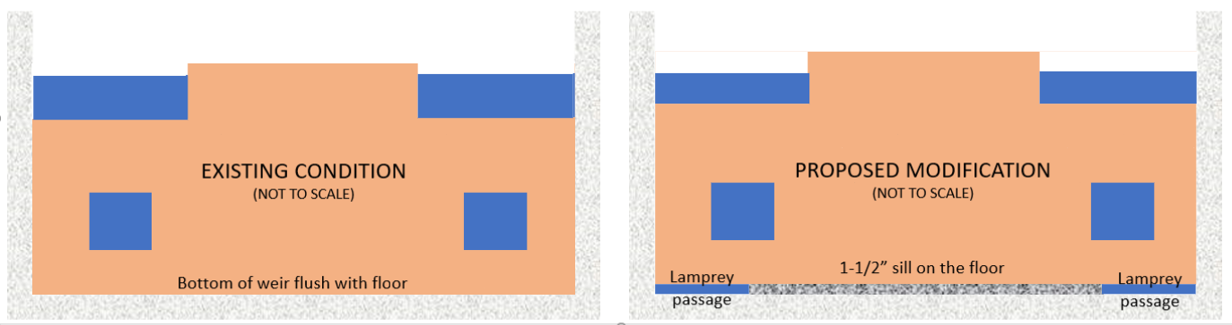
    - from Ralph Lampman to everyone: It makes a lot of sense (at least for lamprey)
    - Charlie Morrill asked about video monitoring for negative salmon interactions.
      - from Nathan Mcclain to everyone: Monitoring was done previously at BON with underwater video.
      - from Kinsey Frick to everyone: Yes, NOAA did study of the floor orifices, but I see Charlie's question on a different design.
      - If the size/shape of the TDA lamprey passage slots is going to be significantly different than the BON floor orifices (previously monitored by NOAA), we should consider video monitoring at TDA.
    - Erick Van Dyke asked about the prevalence of “red lead” paint on other surfaces at TDA and the rest of the dams. Is it everywhere in the system? Is it an environmental hazard we should be concerned about?
    - Nobody on the call today knows enough about the topic to try to answer. FPOM is more likely to have experience with lead paint coatings in attendance. ACTION: Jake (or Erick) will ask about lead paint at FPOM on 4/14.
- BON1 adult lamprey passage improvements – Jeremiah Woodard (PM), Adam White (TL), Andrew Derugin (FC)
  - B-Branch entrance improvements 90% Design Documentation Report (DDR) overview – White
    - 60% DDR available for FFDRWG review on the meeting files website
    - Construction: Winter 2023-2024
  - Elevated orifices in B-Branch – Derugin/Macdonald
    - Started rounding some corners Winter 2021-2022, will finish Winter 2023-2024.
  - Extensive minor modifications to serpentine weirs – Derugin/Macdonald
    - 3 of 9 planned lamprey orifices were installed Winter 2021-2022, will complete the rest with other minor mods Winter 2023-2024.
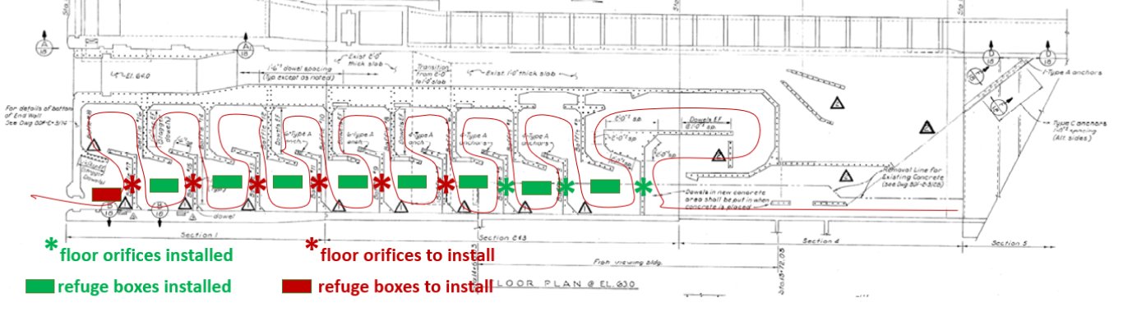
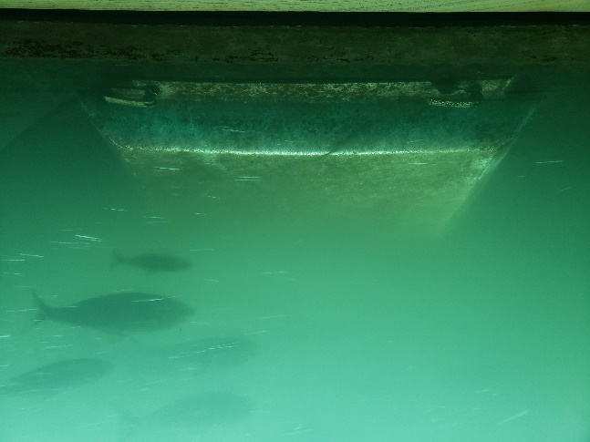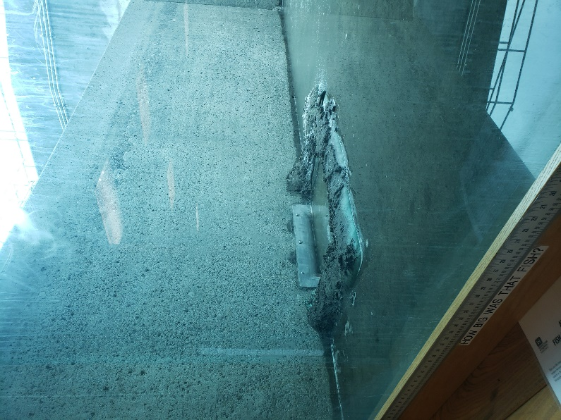
- BON2 adult lamprey passage improvements – Jeremiah Woodard (PM), Shari Dunlop (TL), Andrew Derugin (FC)
  - 30% Design Documentation Report (DDR) – Dunlop
    - 30% DDR available for FFDRWG review on the meeting files website
    - Construction: Winter 2024-2025
    - from Kinsey Frick to everyone: It would be great to know when they are all done if lamprey using the fishway end up passing faster (or more successfully) than before there were orifices.
      - The Lamprey Accords Workgroup is planning a lamprey passage study using acoustic telemetry at BON/TDA in 2025. Route-specific passage success and timing comparable to previous work such as Keefer et al. 2013 will be an objective of that study.

Written project updates
- JDA turbine rehab – Steve Sipe (PM), Curtis Lipski (TL), Jon Rerecich (FC)
- TDA AWS Debris Management– Erin Kovalchuk (PM), Mehdi Roshani (TL), Eric Grosvenor (FC)
- BON Second Powerhouse FGE – Jim Adams (PM), Bridget Bell (TL), Jon Rerecich (FC)
- JDA adult lamprey passage improvements – Jeremiah Woodard (PM), Adam White (TL), Eric Grosvenor (FC)
- TDA adult lamprey passage improvements – Jeremiah Woodard (PM), Adam White (TL), Jake Macdonald (FC)
- BON1 adult lamprey passage improvements – Jeremiah Woodard (PM), Adam White (TL), Andrew Derugin (FC)
- BON2 adult lamprey passage improvements – Jeremiah Woodard (PM), Shari Dunlop (TL), Andrew Derugin (FC)

Fish Facility Design Review Work Group (FFDRWG)

USACE, Portland District

Project Update
Date Prepared/Updated: 2022-4-1

JDA Turbine Rehab
Project Identifier: | P2 #
Project Manager (PM): | Steve Sipe (CENWP-PMF-P)  Steven.C.Sipe@usace.army.mil
Technical Lead (TL): | Curtis Lipski (CENWP-ENC-HD)  Curtis.L.Lipski@usace.army.mil
FFDRWG Coordination (FL): | Jon Rerecich/Eric Grosvenor (CENWP-PME)  Jonathan.G.Rerecich@usace.army.mil/Eric.Grosvenor@usace.army.mil

Project Description
The purpose of this project is to address reliability concerns and maximize production of hydroelectric power at JDA, which includes electrical energy production and electrical grid ancillary services while at the same time, improving survival of fish passing through the turbines. Maximum production of hydroelectric power at JDA will be realized through increased reliability and increased efficiency. Reliability improvements will be realized through a combination of replacement and refurbishment of powertrain equipment to include, but not limited to, turbine runners, shafting, generators, isophase bus, breakers, switches, and transformers. Efficiency improvements will be realized through increased turbine efficiencies associated with new turbine runners and other modifications to the turbines.
The purpose of this project is also to increase survival of turbine passed fish. Increased survival of turbine passed fish will be realized through developing state-of-art hydroelectric turbines to obtain improved fish passage survival through the turbines. The design of the state-of-the-art turbines will be an iterative and collaborative process that focuses on fish-friendly design features and criteria. This iterative and collaborative design process will be similar to the ongoing Ice Harbor L&D turbine runner replacement design and upcoming McNary L&D turbine runner replacement in NWW. Phase 1A recommendations include replacing up to 14 units with combination fixed blade & adjustable blade to obtain improved fish passage survival through the turbines.

Project Schedule
Phase 1 Short Term Schedule | Start | Finish
30% DDR/P&S review | 3/12/2020 | 4/1/2020
60% DDR/P&S review | 8/28/2020 | 9/18/2020
90% DDR/P&S review | 9/21/2021 | 2/18/2022
BCOES review | 8/15/2022 | 11/25/2022

Overall Schedule Milestones | Date
Contract award | August 2024
Collaborative design process model testing | 2024-2029
First unit installation | 2031-2033
Unit installation complete | 2040-2045

Current Status
- The 1:25 scale physical observational turbine model is being used to inform the development of the Phase 1 Plans and Specifications package, to document the hydraulic conditions that affect the biological performance of the existing JDA turbines and will be used to support the collaborative and iterative design process in Phase 2. Baseline model data collection for Test Series 1 took place from January through June of 2021 with a focus on validating the relocated model and evaluating potential draft tube modifications. The results were used to guide development of the plans and specifications. ERDC prepared a draft data report documenting Test Series 1; this was provided to agency and external partner staff that participate in the PDT in October 2021. Test Series 2 commenced on March 31, 2022. The focus of Test Series 2 will be data collection to document the baseline hydraulic conditions affecting fish survival within the existing turbine environment (e.g., strike, shear and turbulence).
- The 1:45 JDA general physical model and CFD tailrace model are being used to assess hydraulic conditions affecting juvenile egress and adult approach to the fish ladder entrances. Tailrace flow patterns for both models were validated to a single operating condition in 2020. The physical model was used in 2021 to simulate selected scenarios that had been analyzed using CFD during Phase 1A. The results are currently under review by the PDT. Model runs will resume after further HAC modeling is complete and preliminary options for the turbine mix are established.
- The PDT is investigating the possibility of going with oil-free hubs for the adjustable-blade units. Working with PNNL to complete bushing and corrosion fatigue testing.
- 90% DQC and NMFS review has been completed. NMFS had no comment and DQC comments are in review.

Topics for FFDRWG Review/Coordination
None currently.

Fish Facility Design Review Work Group (FFDRWG)

USACE, Portland District

Project Update
Date Prepared/Updated: 2022-1-28

TDA Backup AWS Debris Management EDR
Project Identifier: | P2 #
Project Manager (PM): | Erin Kovalchuk (CENWP-PMF)  Erin.H.Kkovalchuk@usace.army.mil
Technical Lead (TL): | Mehdi Roshani (CENWP-ENC)  Mehdi.Roshani@usace.army.mil
FFDRWG Coordination (FC): | Jon Rerecich (CENWP-PME)  Jonathan.G.Rerecich@usace.army.mil

Project Description
This project is to evaluate alternatives to remove debris from The Dalles Dam Auxiliary Water Supply (AWS) trash rack. Debris build-up on the rack currently causes high head differential across the rack. Fish Unit Rehab requires the AWS backup system to operate during the rehab to provide adequate flow for fish attraction. Fish Unit Rehab duration is one year per unit for a total of two years. Long term use of the backup AWS system will be part of the alternatives evaluation.

Project Schedule

Milestone | Start | End
Criteria and Constraint Report | 4/19/2021 | 8/6/2021
Value Management | 8/9/2021 | 8/20/2021
Alternative Evaluation Report | 8/23/2021 | ?
Draft Final Report | ? | ?
ATR | ? | ?
Final Report | ? | ?
Closeout | ? | ?

Current Status
Value Management Study completed.
No Funding in FY 22
Alternative evaluation Engineering Design Report (EDR) shelved at 50%

Topics for FFDRWG Review/Coordination
PDT will solicit FFDRWG participation at the 60% Engineering Design Report (EDR).

Fish Facility Design Review Work Group (FFDRWG)

USACE, Portland District

Project Update
Date Prepared/Updated: 2022-4-1

BON Second Powerhouse FGE
Project Identifier: | P2 #
Project Manager (PM): | Jim Adams (CENWP-PMF)  James.R.Adams@usace.army.mil
Technical Lead (TL): | Bridget Bell (CENWP-ENC)  Bridget.M.Bell@usace.army.mil
FFDRWG Coordination (FL): | Jon Rerecich (CENWP-PME)  Jonathan.G.Rerecich@usace.army.mil

Project Description
Steel plates were installed in all units in the A and B gatewells to restrict flow. During routine inspections, however, it became apparent that the anchoring system for the steel plates was inadequate. In effect, the nuts and anchoring bolts holding down the plates had come loose, posing the risk that the plates could detach and potentially take out a unit. All flow restriction plates were removed from the units. A concrete corbel will be installed in the same location as the flow control plates with the design goal to achieve similar gatewell hydraulic conditions as the flow control plates. This new concrete corbel has been designed to meet the flow criteria established and tested for the previous flow restrictor plates to meet the hydraulic and biological goals.

Project Schedule
CLIN | Status | Description | Award/Exercise Date | Construction Execution Window
1 | Mandatory | Mobilization/Demobilization | Awarded December 2020 | Complete
2 | Mandatory | Unit 15 Construction | Awarded December 2020 | Complete
3 | Optional | Second Mob/Demob and Unit 11 Construction | Awarded August 2021 | Dec 2022-Feb 2023
4 | Optional | 2 Additional Units | Awarded August 2021 | Extend through May 2023
5 | Optional | 2 Additional Units | Awarded August 2021 | Extend through August 2023
6 | Optional | 2 Additional Units (Unit 18 + 1 more Unit) | Awarded August 2021 | Extend through February 2024

Current Status
- Construction in unit 15 is complete. The contractor did great work, and we had very few RFIs and only one modification.
- Optional construction CLINs were awarded August 2021. We will modify the dates of execution extending them out a year to allow us to test in the spring of 2022 prior to installing the remaining corbels.
- AE contract for hydraulic testing in Spring 2022 was awarded in September 2021. Hydraulic tests will be needed in the spring to meet the upper 1% test range of 18.0-18.5 kcfs.
- Original contract schedule said we would continue with units, 12, 13, 14, 16, and 17 and then end with either 11 or 18 the following IWW. However, the contractor thinks they can do both 11 and 18 in the 2022-2023 IWW and then finish with the remaining units throughout the spring/summer. The PDT is confident they can achieve that after how well unit 15 went. We will confirm their schedule after we get the modification in place.

Topics for FFDRWG Review/Coordination
- FPOM MOC sent on 3/28. Comments are due by April 11.

Fish Facility Design Review Work Group (FFDRWG)

USACE, Portland District

Project Update
Date Prepared/Updated: 2022-4-1

JDA adult lamprey passage improvements
Project Identifier: | P2 # 492402
Project Manager (PM): | Jeremiah Woodard (CENWP-PMF)  jeremiah.j.woodard@usace.army.mil
Technical Lead (TL): | Adam White (CENWP-ENC)  Adam.J.White@usace.army.mil
FFDRWG Coordination (FC): | Jacob Macdonald (CENWP-PME)  Jacob.Macdonald@usace.army.mil

Project Description

Modify NFL LPS to increase the capacity and reliability of the system
This is a fish safety/health issue, and the upgrade needs to happen. Current water supply is insufficient so tank cannot be installed without upgraded water supply. See January 2020 CRS BA § 2.5, pg. 2-85.
- gravity-fed water supply or alternative, more reliable pump configuration.
- larger collection box

SFL entrance improvements (rounded crest, slot cover/filler)
Caps may not be able to be added to South Ladder entrance weir due to FPP submergence criteria, so the weir may need to be modified more extensively to provide rounded weir crests and guide slot covers.

SFL count station collection and counting structure (trap) improvements
Increase capacity and efficiency of system by preventing sediment buildup, providing a larger opening into a larger collection box, modified guide, and removal of gate and counting-related structure.

Project Schedule
Design: FY 2021 – FY 2022
30% DDR – July 2021
60% DDR – November 2021
100% DDR – May 2022
Construction: December 2022 - March 2023
Evaluation/Closeout: FY 2023

Current Status
100% DDR is underway. PDT is moving forward with a gravity feed water supply from behind existing picketed leads near the count station via an existing diffuser drain line. A surplus holding tank at JDA will be modified and relocated to serve as the larger collection box. All work will be performed by Corps staff, no contracts.

Topics for FFDRWG Review/Coordination
60% JDA DDR is available on the FFDRWG meeting files website (http://pweb.crohms.org/tmt/documents/FPOM/2010/FFDRWG/2022%20FFDRWG/)

Fish Facility Design Review Work Group (FFDRWG)

USACE, Portland District

Project Update
Date Prepared/Updated: 2022-4-1

TDA adult lamprey passage improvements
Project Identifier: | P2 # 492403
Project Manager (PM): | Jeremiah Woodard (CENWP-PMF)  jeremiah.j.woodard@usace.army.mil
Technical Lead (TL): | Adam White (CENWP-ENC)  Adam.J.White@usace.army.mil
FFDRWG Coordination (FC): | Jacob Macdonald (CENWP-PME)  Jacob.Macdonald@usace.army.mil

Project Description

Lamprey collection system (LPS) at the east fish ladder junction pool
Provide a ramp (or multiple) for lamprey to swim out of the junction pool and into a collection box located below the upper segment of the fish ladder for upstream transport. See January 2020 CRS BA § 2.5, pg. 2-85.

Modify elevated orifices in EFL exit weirs 154-157
Provide better lamprey passage options through the 4 control weirs at the upstream end of the east fish ladder.

Bulkhead slot covers
Design and install bulkhead slot covers at all four fishway entrances.

Project Schedule
Design: FY 2021 – FY 2023
30% DDR – August 2021
60% DDR – February 2021
90% DDR – September 2022
BCOES – November 2022
Construction: December 2023 - March 2024
Evaluation/Closeout: FY 2024

Current Status
90% DDR is underway. Preferred LPS design includes gravity-fed water supplied from an existing auxiliary penstock in the dam, a large collection box on the deck near the junction pool, and 1-3 climbing ramps reaching down to the fishway floor.

Topics for FFDRWG Review/Coordination
Lead paint on exit weirs 154-157
- Cannot cut or drill into existing weirs without lead paint remediation
- estimated cost of new weirs = $1 Million, estimated cost to modify existing weirs = $750,000 - $1 Million
- PDT is exploring an option using the existing weirs without modification
30% TDA DDR is available on the FFDRWG meeting files website. Will replace with 60% when it is ready.

Fish Facility Design Review Work Group (FFDRWG)

USACE, Portland District

Project Update
Date Prepared/Updated: 2022-4-1

BON1 adult lamprey passage improvements
Project Identifier: | P2 # 492400
Project Manager (PM): | Jeremiah Woodard (CENWP-PMF)  jeremiah.j.woodard@usace.army.mil
Technical Lead (TL): | Adam White (CENWP-ENC)  Adam.J.White@usace.army.mil
FFDRWG Coordination (FC): | Jacob Macdonald (CENWP-PME)  Jacob.Macdonald@usace.army.mil

Project Description
The project scope is divided into three parts:

Entrance Modifications
Modify the B-branch fish ladder entrance to improve lamprey passage. This includes a variable-width entrance weir with rounded edges, guide slot fillers or covers to aid lamprey passage along the walls, and bollards on the channel floor for hydraulic refuge.

Lamprey Collection
Provide an alternate route for lamprey entering the B-branch of the Bradford Island fish ladder. Fish would climb up a flume structure to a holding tank on the deck of the dam and be transported upstream by Tribal fisheries personnel. This will be designed so that in the future we could extend the system to provide volitional passage to the Bonneville forebay.

Serpentine Section Extensive Minor Mods
Upgrade the serpentine section of the Bradford Island fish ladder to improve lamprey passage by rounding corners, providing refuge boxes, and lamprey orifices.

Project Schedule
Design: FY 2021 – FY 2022
30% DDR – July 2021
60% DDR – November 2021
90% DDR – August 2022
BCOES – October 2022
Construction:
Advertise Contract – January 2023
Award Contract – April 2023
Installation - December 2023 - March 2024
Evaluation/Closeout: FY 2024 - FY 2025

Current Status
90% DDR is underway. PDT is refining the LPS climbing flume alignment.

Topics for FFDRWG Review/Coordination
60% BON1 DDR is available on the FFDRWG meeting files website.

Fish Facility Design Review Work Group (FFDRWG)

USACE, Portland District

Project Update
Date Prepared/Updated: 2022-4-1

BON2 adult lamprey passage improvements
Project Identifier: | P2 # 492401
Project Manager (PM): | Jeremiah Woodard (CENWP-PMF)  jeremiah.j.woodard@usace.army.mil
Technical Lead (TL): | Shari Dunlop (CENWP-ENC)  Shari.L.Dunlop@usace.army.mil
FFDRWG Coordination (FC): | Jacob Macdonald (CENWP-PME)  Jacob.Macdonald@usace.army.mil

Project Description
Full redesign of control section (EDR/DDR, P&S, Construction).
2020 CRS BA Chapter 2: Proposed Action (pg.2-85): “This measure would modify the serpentine-style flow control sections of Bonneville Dam’s Washington Shore and Bradford Island fish ladders, converting them to Ice Harbor-style vertical slot with submerged orifices configurations. This would improve passage conditions for adult lamprey and likely reduce stress and delay for adult salmon, steelhead, and bull trout. All full-duplex passive integrated transponder (PIT) arrays currently located in the control sections of these ladders would be replaced in kind or improved to maintain or enhance current levels of detection of PIT-tagged anadromous fish.

Project Schedule
Design: FY2021-FY2024
Construction: Winter 2024/2025
Evaluation/Follow-on: FY2025-FY2026
Closeout: FY 2027
Preliminary Milestones:
- Project Kick-Off: ~ August 2021
- 30% DDR: ~ January 2021
- 60% DDR: ~ June 2022 *FFDRWG review ~July 2022
- 90% DDR: ~ October 2022 *FFDRWG review ~November 2022
- Draft-Final: ~ December 2022 *FFDRWG review ~December 2022
- [Start P&S after 90% DDR DQC is complete, ~November 2022]

Current Status
Screening-level hydraulic analysis was completed for four variations to achieve the CRS BA proposed action of replacing the serpentine control section with a vertical slot and orifice configuration. A site-specific cost estimate determined that the total project cost (not including evaluation/follow-on) would be in the $5M to $7M range. The PDT is now setting up 3D CAD and computational fluid dynamics (CFD) models to support the DDR design development work. PSMFC is additionally working on designs for the new PIT antenna arrays. The 30% DDR DQC is complete, and comments are being addressed by the PDT.

Topics for FFDRWG Review/Coordination
30% BON2 DDR is available on the FFDRWG meeting files website
